

2026 Planned Club Events

Date | Description
February 20-21 | Otter Creek Camping Trip
March (TBD) | Westover Farms, MO
March 14 | St. Pat’s Day Parade
May 6-10 | Green-Sullivan State Forest & Shakamak State Park, IN
May 6-8 | Green River,  Greensburg, KY
June 5-6 | Cumberland River, KY
June 13-20 | Waterfalls Lodge, Spanish  Ontario Canada
June 29-30 | New river, Meadow Creek WV
July 9-10 | Obey River, Celina TN.
July 11-12 | Cumberland River
August 15-16 | Cumberland River
August (TBD) | Cody, Wyoming
September (TBD) | Ausable river, MI
November 11-14 | Maggie Valley, NC
December 16 | Christmas Party

-subject to change (check website for updates)

Thank you to the presenters, vendors and organizations who are participating and continue to support DCFF and our annual show!

Also, a special thanks to all our members and volunteers who make this show possible !

Steve Kuric, Fly show director
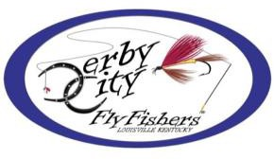
Michael Broome, President

Mission
The mission of Derby City Fly Fishers (DCFF). is based on three(3) core principles, Education, Conservation and Fellowship.

It is our goal to stimulate interest in fly
fishing for all species of fish, on all waters.

Educational Meetings Fly Tying Workshops
Casting Instruction & Competition
Beginner’s Outings Organized Trips Youth Activities
Annual Fly Fishing Show Rod Building


- Meet & Greet – 2nd Wednesday of Each Month

- General Meeting – 3rd Wednesday of Each Month

- Free Fly-Tying Instruction – 4th Wednesday & Thursday of Each Month

19th Annual
Kentuckiana Fly Fishing Show
Saturday, January 17,2026 9:00am to 4:30pm
Presented By

Retailers Guides

Seminars

Fly Tying

Fly Casting

Chances

Silent Auction
Paroquet Springs Conference Center
395 Paroquet Springs Drive
Shepherdsville, Ky

www.derbycityflyfishers.com

Presentation Schedule Silent Auction & Chances 2026 Fly Show Floor Layout
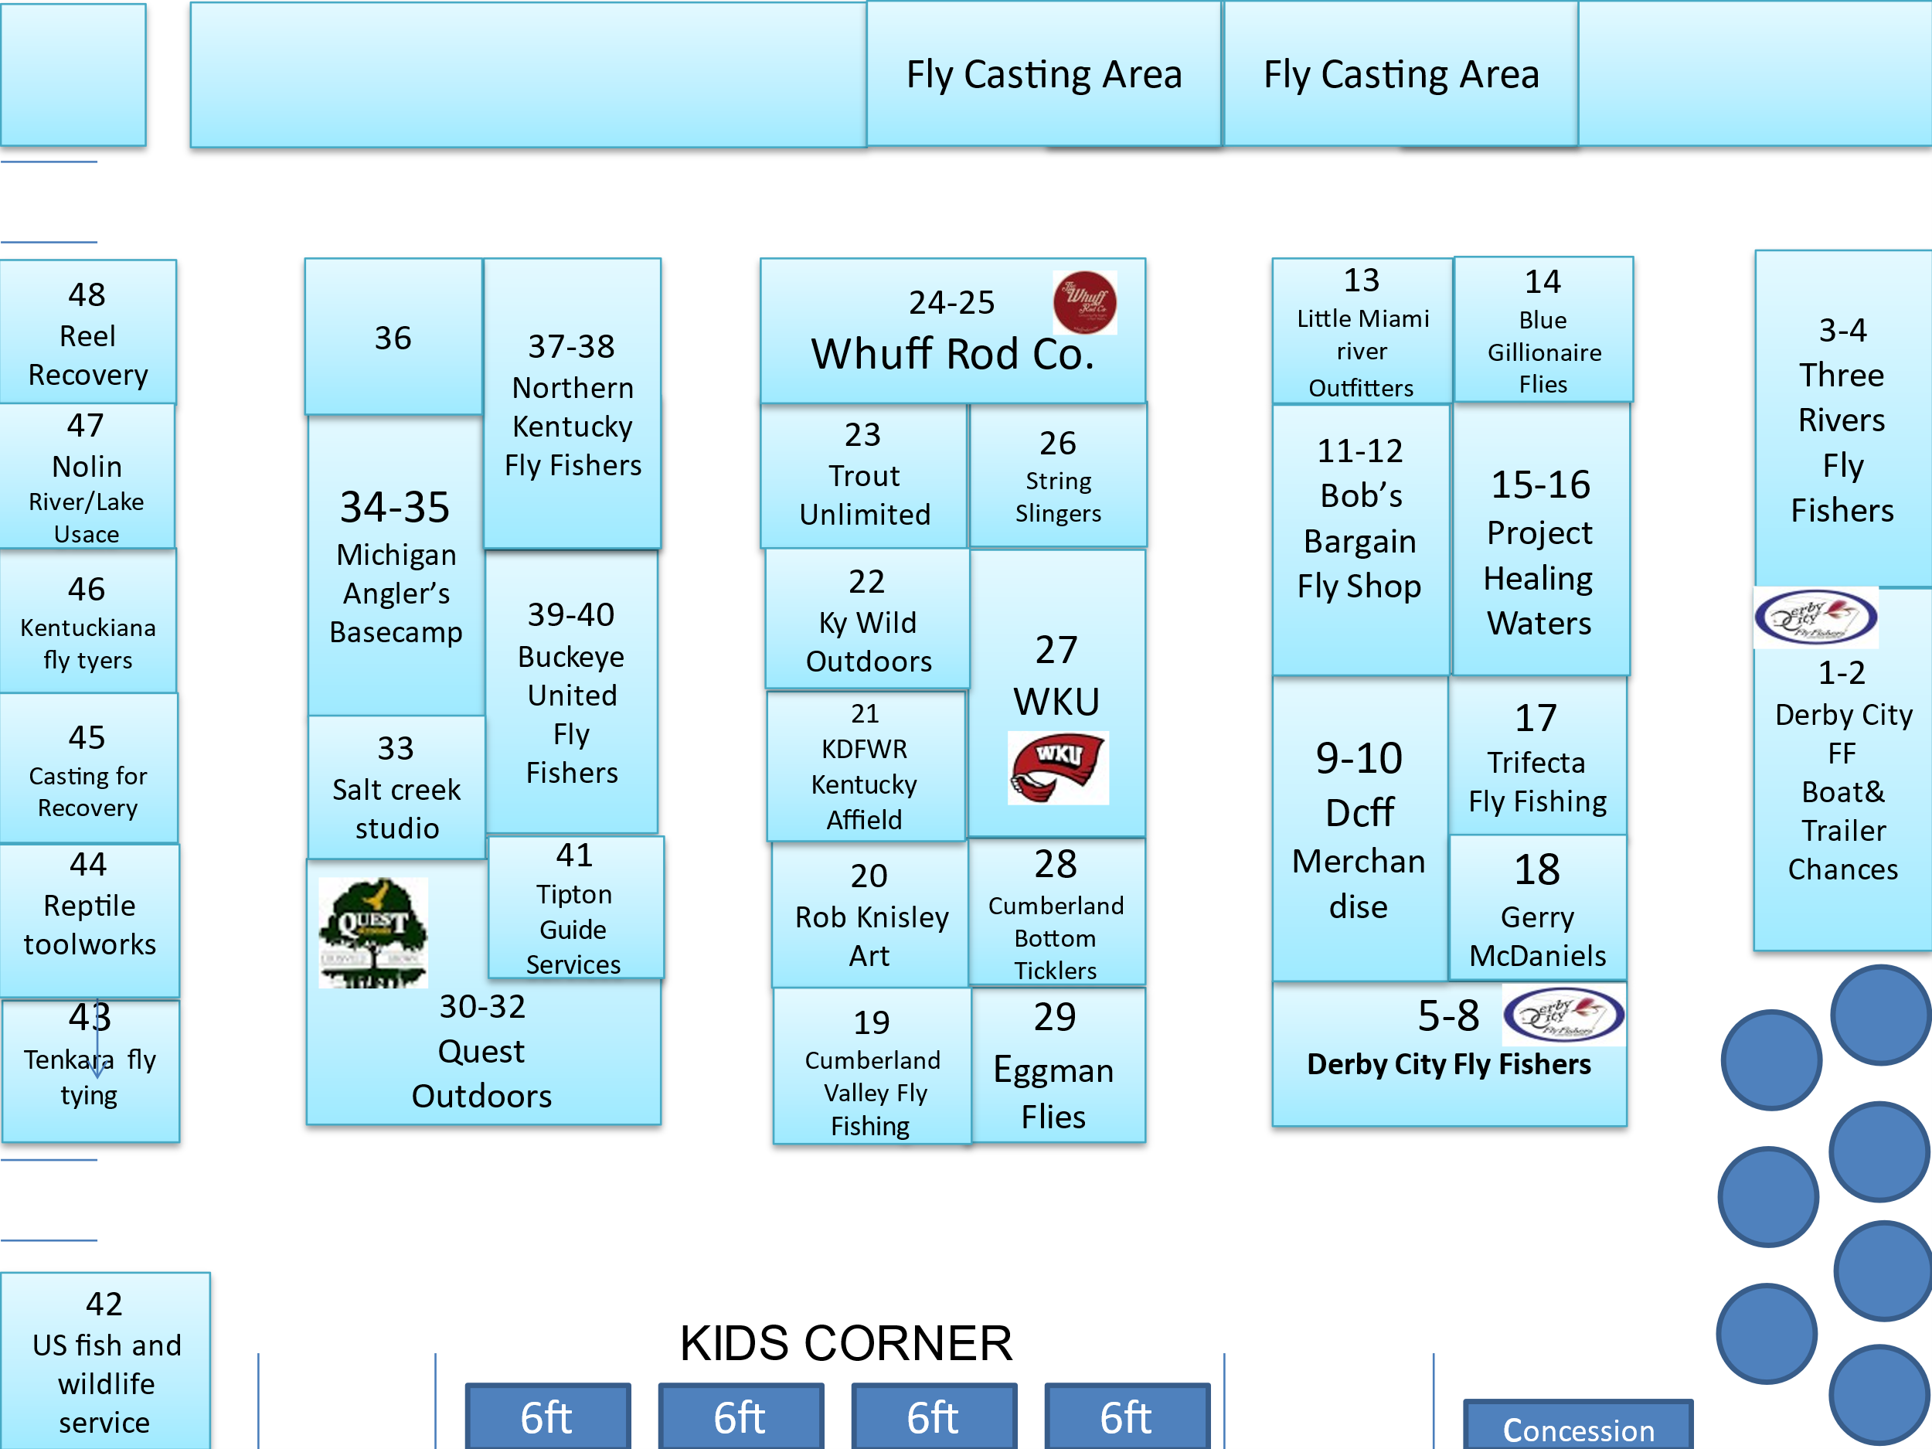

9:30-10:15 Jim Sauerheber -Bowing Green, Ky
(Cumberland Valley Fly Fishing)
Fly fishing on the Cumberland River, what you need to know!
He has been passionate about fishing his whole life and discovered fly fishing in his early adulthood. He began his guide service in 2011 on his homewaters, the Cumberland and Barren rivers. He has published in the summer 2024 edition Dark Skies and Derby City Fly fishers the quarter pole 2025Q1. He has also presented to regional fly fishing clubs, BUFF,DCFF,NKFF,MTFF and IFC.

10:30-11:15 Bill Carman -Lexington, Ky
(Kentucky wild LLC)
Fly Fishing the Red River Gorge-Update

A Fly fishing guide with over six decades experience fishing streams in Kentucky, specializing in small stream fishing. He is the winner of the national Outdoor Life Book Club short story contest and he has also written multiple hunting/fishing books. His latest book is Fishing with Daniel Boone. Previously a landscape architect, he also spent ten years as the Ky-Tn-Wv regional director for the Rocky Mountain Elk Foundation.

11:30-12:00 Michael Broome -Louisville, Ky
(President / Derby City Fly fishers)
Welcome and Introduction, Update.

1:00-1:45 Lee McClellan -Franklin, Ky
Blue Water Trails: Paddle Perfect, Kayak fishing on Ky State owned lakes.
Lee is the associate editor for the Kentucky Afield Magazine with a passion for fishing. He is the author of the award-winning Blue Water Trails series of articles profiling fishing and paddling across Kentucky.
He is the author of dozens of stories for the Kentucky Field Magazine.

2:00-2:45 Jesse Vault -Bowling Green,Ky
Fly fishing for Striped Bass on the Cumberland
River
Jesse Vault a 28 years old father of 2 was born and raised in Fort. Collin’s Colorado where his fly-fishing journey began, learning to fly fish as a young adult through the Rockies. He Re-located to Bowling Green Kentucky in January of 2020.String Slingers provides guiding services on the waters of southern Kentucky region from the Cumberland river in Jamestown KY including the Green River and Barren River of Bowling Green KY and the tributaries in-between. Offering casting and tying lessons along with guided trips, String Slingers is ready to help you build confidence for your next adventure!
Vendors/Supporters will include:
- Quest Outdoors
- Rob Knisley Art
- Western Kentucky University
- Salt Creek Studio
- Kentucky Wild Outdoors
- Cumberland Bottom Ticklers
- Blue Gillionaire Flies
- The Whuff Rod Co.
- Kentuckiana Fly Tyers
- Eggman Flies
- US Fish & Wildlife
- KY Dept of Fish & Wildlife
- KY Afield
- Trout Unlimited
- Little Miami River Outfitters
- Cumberland Valley Fly Fishing
- String Slingers Guide Services
- Bob’s Bargain Fly Shop
- Trifecta Fly Fishing
- Reptile Toolworks
- Tipton Guide Services

14’ John Boat with trailer and trolling motor.

Lamson Waterworks
Litespeed F5+Reel Fuego

CUSTOM FLY BOX W/CUSTOM FLIES
Kentuckiana Fly Tyers

Bourbon Bundles
Bullet Bourbon
Buffalo trace

Fishpond Thunderhead Submersible
Sling Pack

Fishpond Summit Sling Pack
With beginner essentials.

Fly Fishing Rod 7wt 9’ 4pc
“Streamer Stick”
The Whuff Rod Co.-Dave Huff

Much More to Come!
Come to the Fly Show!!!

www.derbycityflyfishers.com
