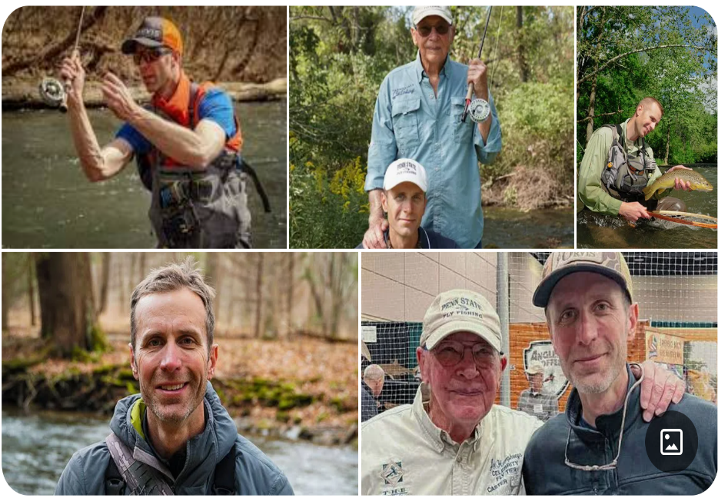
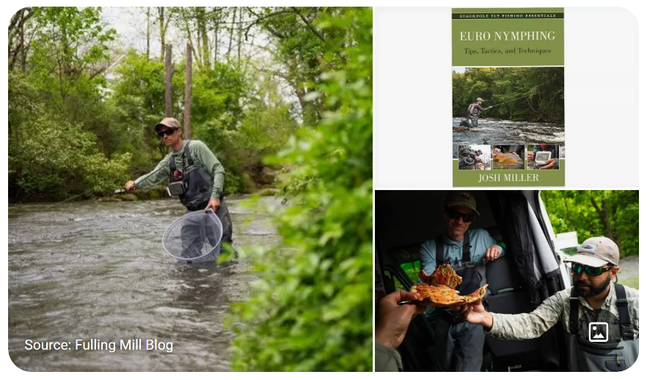
George Daniel is a member of Fly Fishing TEAMUSA, and a two time Fly Fishing U.S. National Champion. [2] He has competed in four World Fly Fishing Championships, sponsored by Fédération Internationale de Peche Sportive Mouche (International Sport Flyfishing Federation). In 2006, competing in a field of 110 in the world championships held in Portugal, he finished in fifth place, the second best result ever by a competitor from North America. He also competed in the 2007 world championships in Finland,[3] the 2008 world championships in New Zealand[2] and the 2009 world championships in Scotland. Daniels lectures across the country on fly fishing,[1][4] and his favorite technique, "dynamic nymphing". [5] His book on dynamic nymphing was published in 2011.
In 2009, sportswriter Charlie Meyers of the Denver Post wrote that "a compelling case can be made for George Daniel as the best fly-fisherman in the country."[4]

Josh Miller was a member of the Fly Fishing Team USA from 2016 through 2020, and recently led the US youth team to a gold medal in the 2023 World Championship in Bosnia. He has competed in the regional and national competition circuits and has assisted in coaching three world youth fly fishing championships. Miller is a full-time guide and traveling instructor and is a signature tier for Orvis, Fulling Mill, and others. Miller endorses Thomas and Thomas rods and Scientific Anglers. He lives with his wife, Sarah, and son, Jonah, in western Pennsylvania

